Escuela Secundaria General
“Manuel José Othón”

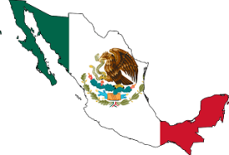
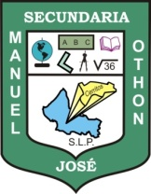
My Dictionary

English-Spanish Spanish-English

Teacher's name: JUAN MANUEL GUERRERO MARTÍNEZ

Student's name:

Grade: FIRST

Group:

