Escuela Secundaria General
“Manuel José Othón”

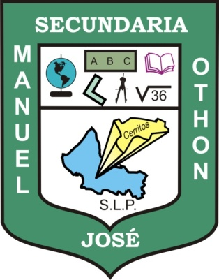

PORTFOLIO OF EVIDENCE

Teacher's name: JUAN MANUEL GUERRERO MARTÍNEZ
Student's name:
Grade: FIRST
Group:

Cerritos, S.L.P. JUNE 12TH, 2013

