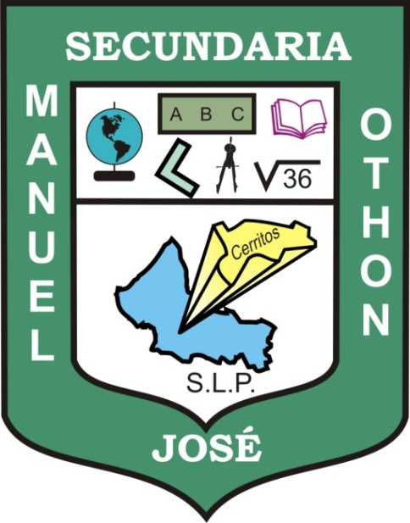
Escuela Secundaria General
“Manuel José Othón”

WORKBOOK
ENGLISH 3

Teacher's name: JUAN MANUEL GUERRERO MARTÍNEZ
Student's name:
Grade: THIRD
Group:

Cerritos, S.L.P. August 22, 2011

