Escuela Secundaria General
“Manuel José Othón”

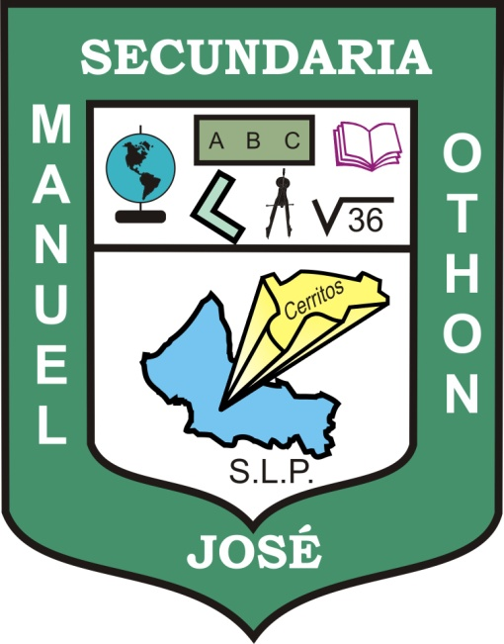

PORTFOLIO OF EVIDENCE

Teacher's name: JUAN MANUEL GUERRERO MARTÍNEZ
Student's name:
Grade: THIRD
Group:

Cerritos, S.L.P. August 22, 2011

