Escuela Secundaria General
“Manuel José Othón”

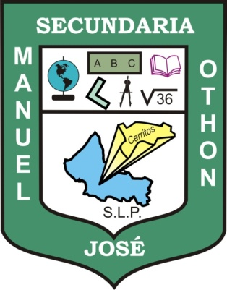

PORTFOLIO OF EVIDENCE

Teacher's name: JUAN MANUEL GUERRERO MARTÍNEZ
Student's name:
Grade: THIRD
Group: “E”

Cerritos, S.L.P. JUNE 18TH, 2012

