ESCUELA SECUNDARIA GENERAL “MANUEL JOSÉ OTHÓN”
CLAVE: 24DES0010G, COL. SANTA CRUZ, CERRITOS, S.L.P.
ENGLISH EXAM FIFTH BIMESTER
FIRST GRADE

******************************************************************************************************************************
NAME OF THE STUDENT:__________________________________________________________________
GRADE AND GROUP:_________________

I.- MATCH THE COLUMN A WITH THE COLUMN B WITH THEIR CORRESPONDING MEANING

SD) SQUARE ( ) TIENDA DE MÚSICA
AZ) RESTAURANT ( ) PARQUE
ÑO) BOUTIQUE ( ) MUSEO
WS) MUSIC STORE ( ) PLAZA
ED) POST OFFICE ( ) GIMNASIO
RF) SUBWAY STATION ( ) CIBERCAFÉ
TG) ZOO ( ) RESTAURANTE
YH) PARK ( ) OFICINA POSTAL
UJ) GYM ( ) ESTACIÓN DE AUTOBUSES
IK) FIRE STATION ( ) METRO
OL) CAFÉ ( ) BOUTIQUE
PÑ) CYBERCAFÉ ( ) GASOLINERA
AZ) TRAVEL AGENCY ( ) ZOOLÓGICO
SX) BUS STATION ( ) ESTACIÓN DE BOMBEROS
DC) MUSEUM ( ) AGENCIA DE VIAJES
FV) GAS STATION ( ) CAFÉ

II.- WRITE SENTENCES ABOUT WHAT THERE IS OR THERE INS´T IN THE CITY MAP.
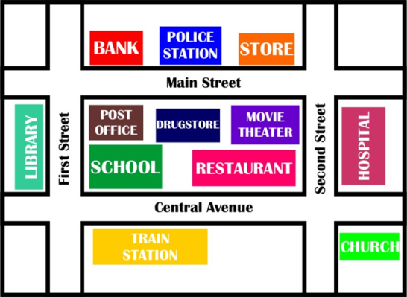
(FOLLOW THE EXAMPLE)
EXAMPLE: THERE IS A BANK IN MAIN STREET

A) ___________________________________________________
B) ___________________________________________________
C) ___________________________________________________
D) ___________________________________________________
E) ___________________________________________________
F) ___________________________________________________
G) ___________________________________________________
H) ___________________________________________________
I) ___________________________________________________
J) ___________________________________________________

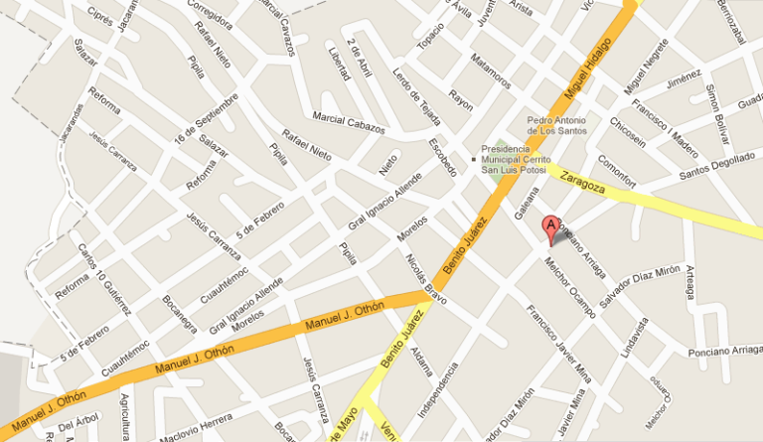
How can I get to Banamex bank?

