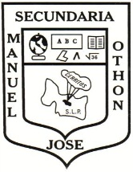
ESCUELA SECUNDARIA GENERAL “MANUEL JOSÉ OTHÓN”
CLAVE: 24DES0010G MACLOVIO HERRERA Y BOCANEGRA
CERRITOS, S.L.P. TEL 01 4868632026
ENGLISH EXAM SECOND GRADE

NAME: ________________________________________________________GROUP:________

I. - MATCH THE TWO COLUMNS WITH ITS CORRESPONDING MEANING
) Piloto
) Amigo
) Estilista
) Cantante
) Maestro
) Astronauta
) Cocinero
) Diseñador
) Paciente
) Camarero(a)
) Enfermera
) Botones
) Albañil
) Estudiante
) Secretaria
) Taxista
) Doctor
) Carpintero
) Bombero
) Mujer policía

( ) hairdresser
( ) bell-boy
( ) Mason
( ) Chef
( ) Waitress
( ) Carpenter
( ) Pilot
( ) Teacher
( ) Doctor
( ) Designer
( ) Taxi driver
( ) Astronaut
( ) Secretary
( ) Policewoman
( ) Fireman
( ) Patient
( ) Singer
( ) Nurse
( ) Student
( ) Friend

II.- USE THE PHRASES IN THE BOX BELOW TO WRITE A SENTENCE ABOUT WHAT EACH PERSON CAN OR CAN´T DO.

Design churches fix your hair help tourist help doctors create a computer game
Drive tractors work with a hammer take orders from menus carry luggage cook chicken and vegetables build a house operate on sick people

1.- A chef
2.- A mason
3.- A waitress
4.- A bell boy
5.- A carpenter
6.- A hairdresser
7.- A doctor

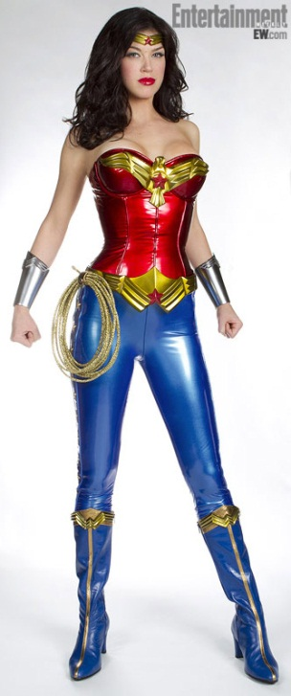
III.- WRITE A DESCRITION ABOUT WONDER WOMAN USING THE ADJECTIVES BELOW.

Short Medium Plump Slim Black Curly
Tall Black height big blond

This is the wonder woman she is
_________________________________________________________________________________________________________________________________________________________________________________________________________________________________________________________________________________________________________________________________________________________________________________________________

