Escuela Secundaria General
“Manuel José Othón”
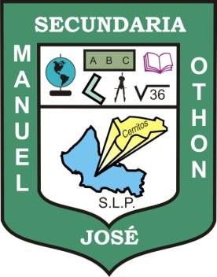

My Dicctionary

English-Spanish
Spanish-English

Teacher's name: JUAN MANUEL GUERRERO MARTÍNEZ

Student's name:

Grade: THIRD

Group:

